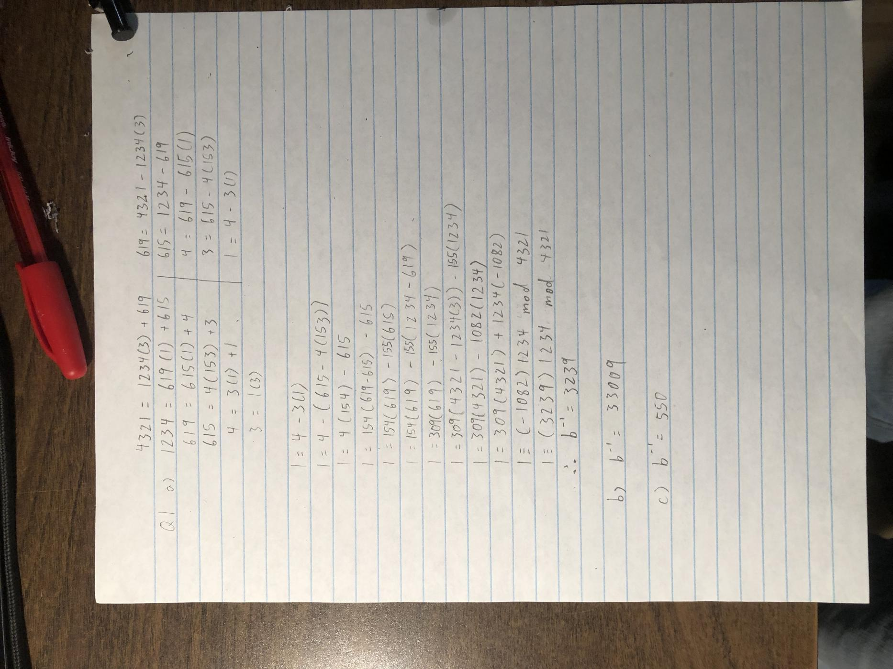

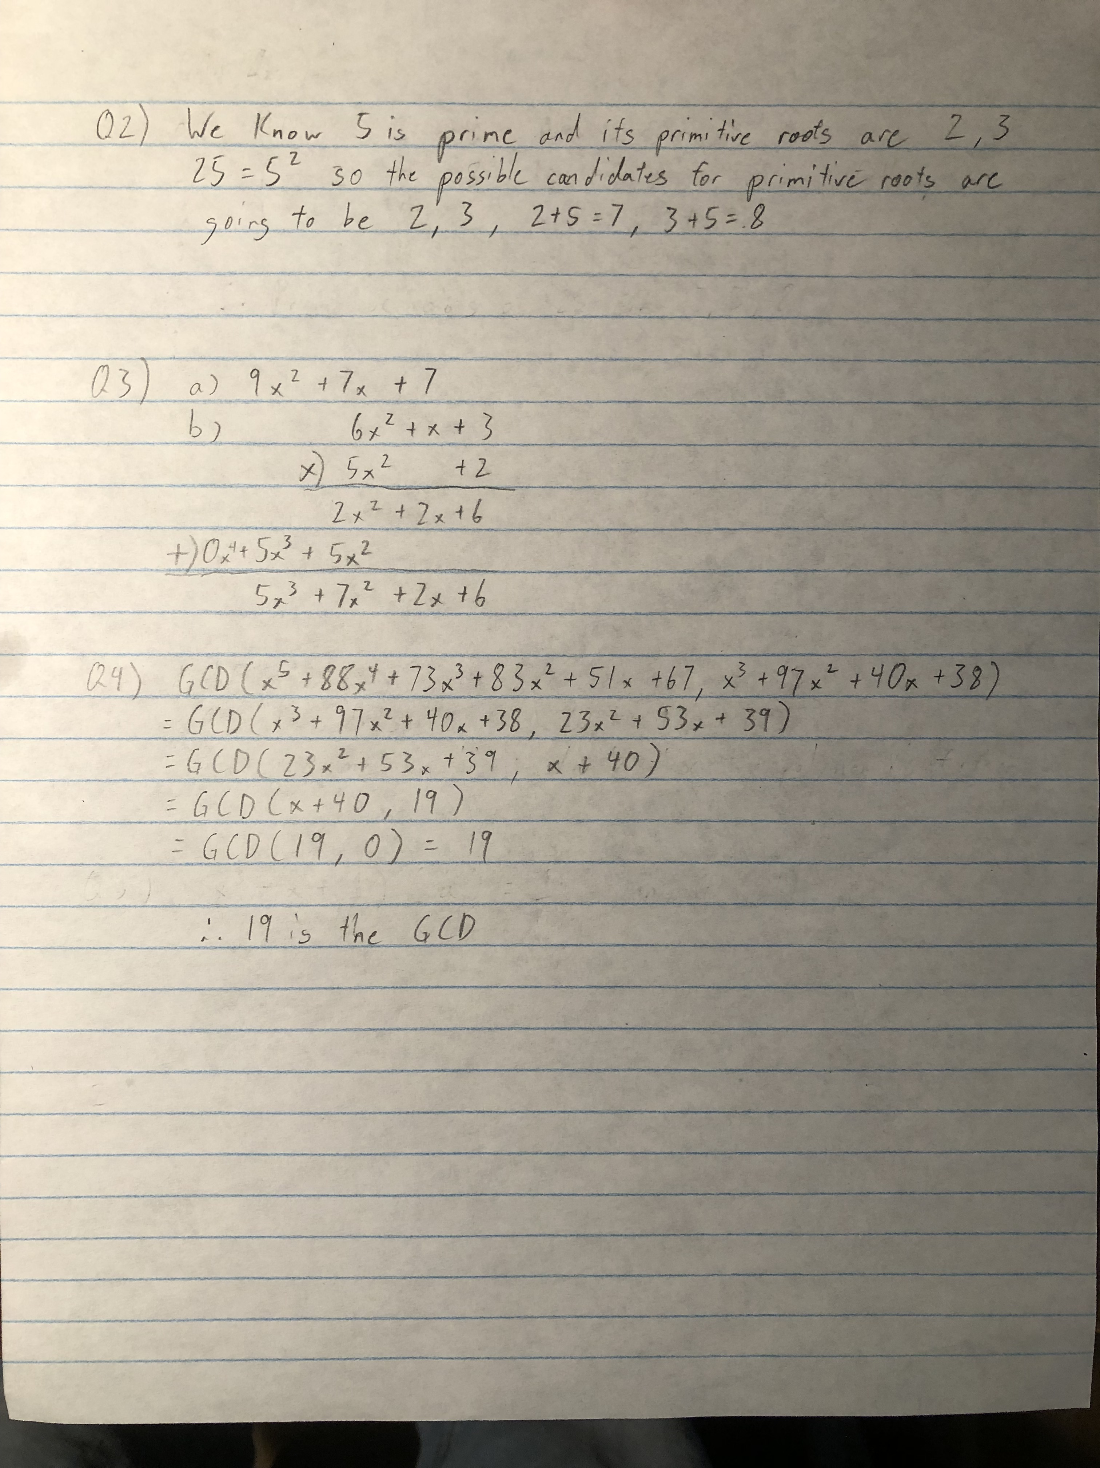

We test the 4 possible candidates for primitive roots.

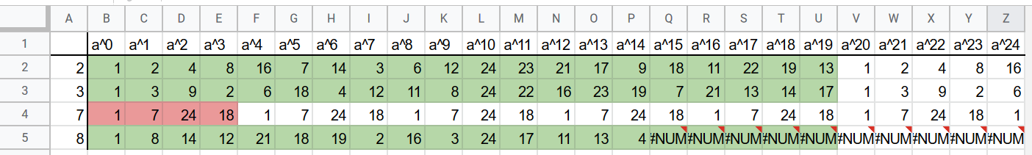

The numbers 2, 3, and 8 have cycles of length 20 which is exactly φ(25). So they are primitive roots. (Even though 8 is not fully shown, 23 = 8, so it would also have a cycle.) The number 7 only has a cycle of 4 so it will not be a primitive root.



